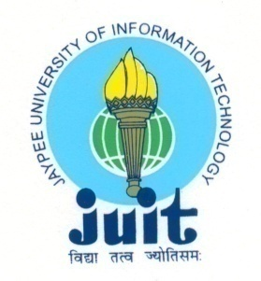 | JAYPEE UNIVERSITY OF INFORMATION TECHNOLOGY  (Established by H.P.State Legislative vide Act No. 14 of 2002)  Waknaghat, P.O. Dumehar Bani, Kandaghat, Distt. Solan – 173234 (H.P.) INDIA  Website :www.juit.ac.in  Phone No. (91) 01792-257999 (30 Lines)  Fax : (91) 01792 245362

NAAC Criteria Supporting Document
Criteria 4

4.2.1 Summary Sheet

Criteria | Criterion IV – Infrastructure and Learning Resources
Key Indicator | 4.2 Library as a Learning Resources
Metric | 4.2.1: Library is automated using Integrated Library Management System (ILMS) and has digitisation facility.

Additional Information
Sr. No. | Document Title | View Document
1 | Library Management System | View
2 | Library website | View
3 | Geo-tagged Photos | View

